Modern Slavery Statement 2023
Melbourne Water

Table of contents
Introduction 3
About Melbourne Water 4
Structure, operations and supply chains 5
Risks of modern slavery practices in Melbourne Water’s operations and supply chains 9
Actions taken by Melbourne Water to assess and address modern slavery risks 12
How we assess effectiveness 23
Progress update 24

Introduction
Melbourne Water Corporation (Melbourne Water) is responsible for managing our waterways, delivering affordable and clean water to the community and keeping our people healthy with effective sewerage services.
In order to achieve this, Melbourne Water’s diverse and capable teams work with the community, developers and a wide range of partners, contractors and suppliers. Melbourne Water’s values are intrinsically linked to everything we do and how we engage the organisations that we work with. For this reason, Melbourne Water is committed to working to ensure our operations and supply chain are free of modern slavery.
This Modern Slavery Statement (the Statement) is Melbourne Water's response to the requirements of section 13 of the Australian Commonwealth Modern Slavery Act 2018 (Cth) (Modern Slavery Act). It has been prepared for the reporting period 1 July 2022 to 30 June 2023 (Reporting Period). Melbourne Water does not own or control any other entities in preparing this Statement.

The Statement has been approved by the Board of Melbourne Water on 27 October 2023 and has been signed by Greg Wilson (Chair) and Nerina Di Lorenzo (Managing Director), who are authorised to sign this statement on behalf of Melbourne Water.

Greg Wilson, Chairman | Dr Nerina Di Lorenzo, Managing Director

About Melbourne Water
The reporting entity under the Modern Slavery Act is the Melbourne Water Corporation (Melbourne Water), a water corporation established under section 85 of the Water Act 1989 (Vic).

For over 130 years, Melbourne Water has been serving the community by planning and building for our future. We manage water supply catchments, treat and supply drinking and recycled water, remove and treat most of Melbourne’s sewage, and manage catchments, waterways and major drainage systems in the Port Phillip and Westernport regions.

Much of the infrastructure created over that time is still in use today – a testament to the ingenuity and foresight of those who came before us. We are continuing this legacy by building new and resilient infrastructure to meet the challenges of today and the future, while keeping costs as low as possible. Guided by our visionary three pillars of creating Healthy People, Healthy Places and a Healthy Environment, Melbourne Water’s passionate team of experts helps make greater Melbourne a fantastic place to live.

We work hard to deliver sustainable public health, financial and environmental solutions (such as providing affordable, clean water for homes, gardens and businesses, keeping our city clean and people healthy with effective sewerage services) and creating opportunities for community recreation and enjoyment of the land and waterways that Melbourne Water manages. Melbourne Water does not work alone. We engage and collaborate with a wide range of partners that include Melbourne’s retail water companies, councils, developers, contractors, Traditional Owners, the community and government agencies to deliver services our customers value. We build strong relationships with our customers, stakeholders and suppliers in the community, government and industry, and care for the health and wellbeing of our people.

Structure, operations and supply chains
Introduction
Melbourne Water plays an integral role in helping to build the modern liveable city we see today. We continually examine how we can evolve our business to ensure we are meeting the challenges we face by listening to our customers, empowering our people, utilising technology and continuing to deliver world-class services.

Melbourne Water’s operations and supply chain have not materially changed from the previous Reporting Period to this current Reporting Period. For this reason, this year’s Statement presents similarities to and builds on Melbourne Water's FY22 Modern Slavery Statement. Notwithstanding, Melbourne Water is steadfastly committed to an ongoing journey of enhancing governance structures and improved data-driven performance. These efforts are integral to our actions to address the risk of modern slavery in both our operations and supply chains.

Organisational Structure
Melbourne Water has undergone an organisational transformation during this period. This initiative aims to enhance our business performance, create a more efficient working environment, and align us with our strategic objectives for the present and future.

Our organisational structure has evolved as a result of this initiative. We have consolidated our portfolios and introduced a new leadership structure to align with our strategic goals. These changes in our structure were effective from Dec 2022; the changing structure is illustrated below and represents executive appointments as at 30 June 2023:
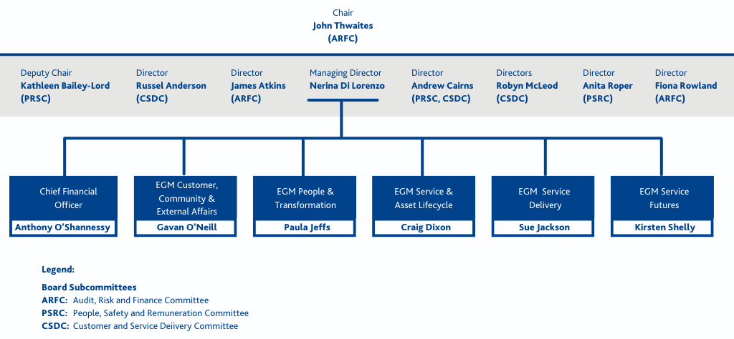

Our people
As at June 2023, Melbourne Water employed 1,277 employees (963 full time employees, 202 part time employees and 112 fixed term and casual employees). 64.4% of our staff work from our head office located at Docklands in Melbourne and 35.6% work on operational sites including treatment plants, pumping stations, regional offices and reservoirs across Victoria.

Melbourne Water has two Enterprise Agreements which provide terms and conditions, including hours of work and pay, to a majority of its employees. Melbourne Water has separate Management Agreements that provide terms and conditions for senior and executive level employees.

The Enterprise Agreements – Melbourne Water Enterprise Agreement 2020 (EA) and Melbourne Water (Waterways and Land Delivery) Enterprise Agreement 2021 (WLD EA) – are negotiated every three or four years with the respective unions, are governed by the State Government’s Industrial Relations policies and require approval from the Fair Work Commission. Both Agreements are made available to all employees upon commencement of employment and remain available to employees through the Melbourne Water intranet. 45% of Melbourne Water's employees are covered by the EA and 12% are covered by the WLD EA.

40.3% of Melbourne Water employees are Senior Managers and are covered by either Senior Management Contracts or Executive Management Agreements, and 2.7% are casual staff employed under casual contracts.

Operations and Key Services to Customers

Melbourne Water plays a pivotal role in the Water and Sewerage treatment space, serving as a wholesaler and delivering a range of essential services to benefit the Greater Melbourne region.  Our operations are designed to ensure the well-being of the community and the sustainability of vital resources. Here's a summary of our key services and role as a wholesaler: | 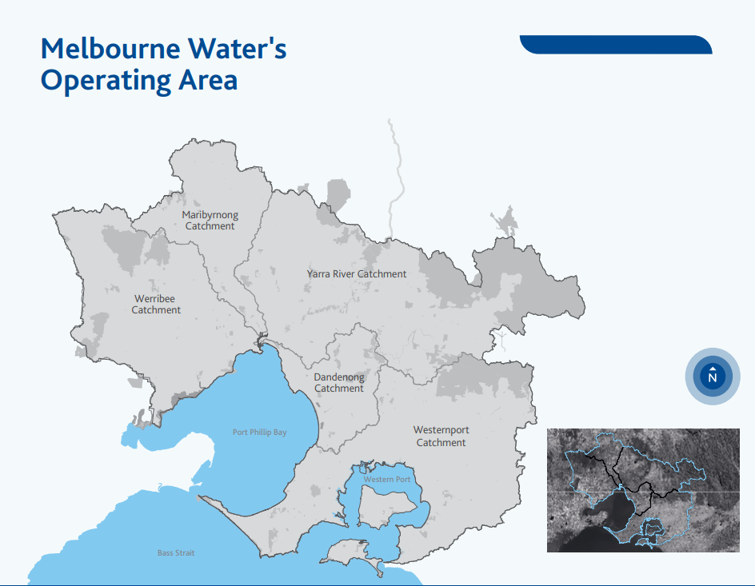

Water Supply
Melbourne Water is dedicated to supplying affordable, high-quality drinking water to the Greater Melbourne region. We manage water supply catchments, treat and supply both drinking and recycled water products, and maintain the water transfer network. Our goal is to meet the water needs of a growing city while ensuring water quality and security.
We supply drinking water to Melbourne’s three retail water companies (Yarra Valley Water, South East Water & Greater Western Water) and other non-metropolitan water businesses which in turn provide water to households and businesses across the Melbourne region.

Sewerage Treatment and Resource Recovery
We are responsible for the efficient and reliable treatment of sewage from most of Melbourne. Through innovative processes, we recover valuable resources from wastewater, contributing to environmental sustainability.

Melbourne’s sewage treatment system consists of two main treatment plants, the Western Treatment Plant at Werribee and the Eastern Treatment Plant at Bangholme. These two treatment plants process approximately 90% of the total sewage generated in Melbourne. A complex sewerage transfer system supports this system by efficiently collecting the sewage from the retail systems and transporting it to one of two treatment facilities.

Waterway and Drainage Management
Melbourne Water takes on the vital task of managing waterways and major drainage systems in the Port Phillip and Westernport region. This includes activities to maintain healthy waterways, integrated drainage management, and enhancing flood resiliency.

Together with councils we play a role in managing most of Melbourne’s drainage system, supplying recycled water to wholesale customers. Wholesale customers include local government, direct service customers and developers. For more detail on operation sites and customers, please refer to our website.

Natural Community Spaces
We are committed to maintaining and preserving outstanding natural community spaces that contribute to the overall well-being of the region. These spaces provide recreational opportunities and support biodiversity, enhancing the quality of life for residents.

Supply Chains
Our annual procurement spend is governed by the provisions of the Victorian Government Procurement Board (VGPB), and our own Procurement Policy and Framework, which guide our activities to ensure that our buying power advances social, economic and environmental objectives. As a Victorian Government-owned organisation, we aim to ensure that our purchases represent value for money and are sourced fairly and ethically.

In FY23:
- Melbourne Water worked with over 2,800 suppliers and spent a total of $1.03b.
- 21% is non addressable spend (taxes, other government agencies, other).
- Over 95% of our spend is represented by 300 suppliers.
- The following table represents a categorisation of addressable spend through our top 300 suppliers in FY23.
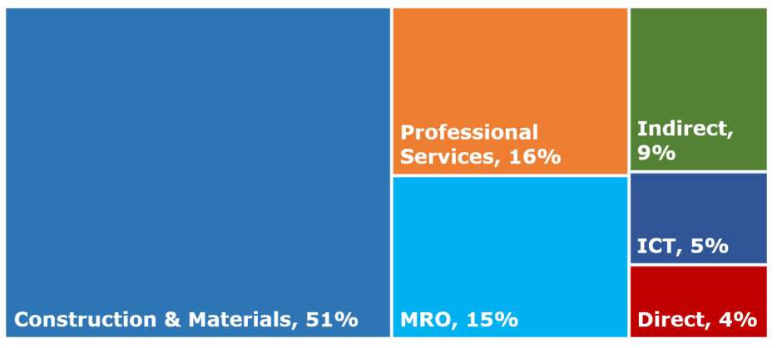

Risks of modern slavery practices in Melbourne Water’s operations and supply chains
Operations
As stated above, during the reporting period the majority of our workforce comprised of permanent employees. Around 2.7% of our workforce is casually employed, primarily working backfilling long term leave or on time-constrained projects. This workforce composition, our union coverage and the fact that our employees are Australia-based, a country with a low risk rating from a modern slavery perspective, led to the conclusion that our workforce which is a large part of our operations, generally posed a low risk.

Supply chain

Geographical Risk Assessment
From a geographical perspective 99.72% of our suppliers are registered Australian businesses. The remaining 0.28% are registered in different countries. The following table represents the countries' modern slavery risk indicators as per the Global Slavery Index 2023.
Country | % spend | Prevalence | Rank  2023 | Vulnerability | Government Response
Australia | 99.72% | 1.6 | 147 | 7 | 67%
India | 0.10% | 8 | 34 | 56 | 46%
United States | 0.06% | 3.3 | 123 | 25 | 67%
New Zealand | 0.05% | 1.6 | 149 | 8 | 54%
United Kingdom | 0.05% | 1.8 | 145 | 14 | 68%
Singapore | 0.01% | 2.1 | 139 | 24 | 47%
Canada | 0.00% | 1.8 | 144 | 11 | 60%
Ireland | 0.00% | 1.1 | 152 | 9 | 63%
Finland | 0.00% | 1.4 | 151 | 5 | 60%
Netherlands | 0.00% | 0.6 | 157 | 6 | 67%
As per the above table, from the nine countries outside Australia, only India has a medium to high prevalence according to the Global Slavery Index 2023. The other eight countries have a low prevalence index rank.

The following table provides a breakdown on the types of goods or services from companies registered overseas. The type of services or roles required to fulfil these services are high skilled and as such represent low risk.
Country of registration | Number of suppliers | MW Spend range | Services
India | 1 | under $1m | Information Technology
United States | 17 | $500k - $1m | Information Technology and Consulting
New Zealand | 5 | $500k - $1m | Professional Services, Equipment, Maintenance
United Kingdom | 6 | $500k - $1m | Information Technology, Industry memberships
Singapore | 1 | $100k - $500k | Information Technology
Ireland | 2 | $20k-$100k | Information Technology
Finland | 1 | $20k-$100k | Information Technology
Netherlands | 1 | $5k - $20k | Information Technology
IT: Professional Services, Software and Licences

While an entity may be registered or incorporated in Australia or a country with a low prevalence of modern slavery, Melbourne Water acknowledges that risks may differ where a supplier provides a service or manufactures goods in a third country. Refer to ‘Actions taken by Melbourne Water to assess and address modern slavery risks’ for actions that Melbourne Water has taken in order to further monitor this risk.

Subcontractors
Melbourne Water currently works with a handful of Tier 1 service providers for construction, infrastructure maintenance and Information Technology managed services. Refer to ‘Actions taken by Melbourne Water to assess and address modern slavery risks’ for additional information.

Equipment and Materials
While the overall modern slavery risk profile of Melbourne Water is low, there are a substantial number of materials or equipment that are manufactured overseas given the nature of the water and sewage infrastructure network and systems. Many of these products are supplied through Tier 1 recognised manufacturers following design and specification processes managed by Melbourne Water. Notwithstanding, at present, Melbourne Water has limited visibility of where a particular product may be imported from, especially if:
a) the product is purchased from an Australian registered vendor who organises the import,
b) the product is purchased to provide a service through a Tier 1 or Tier 2 provider.

Refer to ‘Actions taken by Melbourne Water to assess and address modern slavery risks’ section for further information on how Melbourne Water is improving this visibility.

Actions taken by Melbourne Water to assess and address modern slavery risks
Operations and supply chain
Melbourne Water has assessed the risk of modern slavery within its operations and employment arrangements, categorising them as presenting a low risk. In alignment with legal requirements, Melbourne Water has established key policies and procedures to foster a respectful workplace and address employee grievances and concerns.

Respectful Workplace Policy
Melbourne Water upholds a comprehensive Respectful Workplace Policy, designed to cultivate an inclusive work environment that is devoid of bullying, discrimination, and harassment. This policy transcends mere legal compliance and commits to eradicating all forms of inappropriate behaviour, including discrimination, harassment, sexual harassment, occupational violence, bullying, and victimization. Any violations of this policy are rigorously investigated and managed in accordance with Melbourne Water's Human Resource Complaint Resolution Procedure.
While these policies and procedures are not exclusively tailored for modern slavery risk management, they serve as integral mechanisms for Melbourne Water employees to report, monitor, and address labour-related complaints and grievances.

Employee Assistance Programme (EAP)
Melbourne Water provides an Employee Assistance Programme (EAP) accessible to all employees and their immediate families. This resource offers confidential support and guidance, fostering a healthy work environment and assisting employees in navigating personal challenges.

STOPline Reporting
Melbourne Water offers an independent and confidential reporting mechanism known as STOPline. This hotline empowers employees and contractors to report instances of improper conduct and breaches of the Code of Conduct. In FY23, STOPline was enhanced to include the capability to report suspected cases of modern slavery. The Melbourne Water intranet and STOPline website provide comprehensive information on indicators of modern slavery, guiding individuals to report their concerns. Reporting can be done by responding to a series of questions, with the option to disclose personal details or remain anonymous.
Melbourne Water remains committed to addressing any potential risks associated with modern slavery and ensuring a workplace that adheres to the highest standards of respect, inclusivity, and legal compliance.

Procurement Risk Assessment
As part of the Vic Water Social Procurement Working Group (SPWG), Melbourne Water collectively developed and piloted a Procurement Toolkit (Toolkit) during the initial two reporting periods, to assist with the identification of labour rights risks, including modern slavery. The Toolkit contains a Labour Rights and Modern Slavery Risk Identification Tool (Risk Identification Tool), a Supplier questionnaires and guidance file, educational material, as well as a Supplier compliance checklist and a Grievance and remediation guidance. These tools are still in use today as part of our tendering process.

Risk Identification Tool
The Risk Identification Tool assists Melbourne Water Buyers to identify the level of risk for each procurement Portfolio and Category. This Excel-based Risk Identification Tool was developed during the initial two reporting periods, piloted in FY21 and subsequently included in the Melbourne Water tender templates for procurement activity with assessed medium to high risk of prevalence of modern slavery. The Risk Identification Tool continues to be used by the Procurement function when approaching the market.

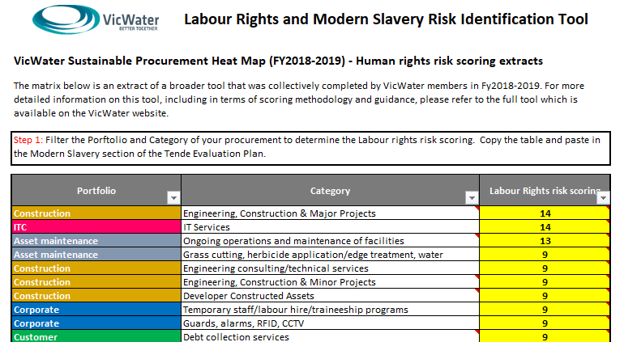

The Risk Identification Tool was developed during the FY20 and implemented during the FY21 reporting periods, and has been subsequently available for utilisation in procurement activity through FY22 to assist Melbourne Water in understanding the Labour Rights risk scoring prior to a market approach. The risk scoring is calculated taking into consideration the likelihood and the consequences of modern slavery in a local water industry context.

As per the Risk Identification Tool, most Melbourne Water procurement categories are low to medium risk, with the exception of Construction which is classified as medium risk.

Portfolio | Category | Percentage of annual spend | Level of Risk
Construction & Materials | Construction services (minor and major projects) and materials related to construction* (pipe, concrete, grates) | 51% | Medium
Professional Services | Temporary staff, labour hire and traineeship programs, security, consulting | 16% | Low to medium
MRO | Above and underground asset maintenance, grass cutting, waterways maintenance | 15% | Low to medium
Indirect | Fleet Services, Energy, Stationery PPE*, Printing, Training | 9% | Low to medium
ICT | Onshore and offshore IT services, cybersecurity consulting, IT equipment | 5% | Low to medium
Direct* | Mechanical and electrical equipment, chemical products (excluding construction materials) | 4% | Low to medium
*Physical goods such as construction materials, equipment and PPE to be further investigated and managed.

Supplier questionnaire and guidance file
The Supplier questionnaire and guidance file (Supplier Questionnaires) contains inherent risk questions as well as closed, open and conversational questions to help Melbourne Water Buyers determine suppliers' labour rights practices. These questions are asked of all prospective suppliers that are in a medium to high risk category during a tender process. In most cases, the closed questionnaire was the most suitable to use in approaches to market over FY23.

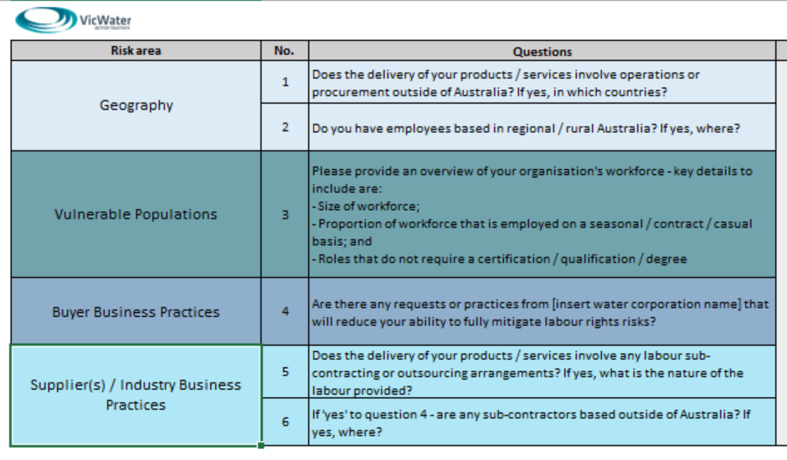 | The inherent risk questions are designed to obtain information to assess risks due to: Geography, Population vulnerability and Business practices affecting the industry.

The Supplier Questionnaires contain closed, open and conversational questions.  For example, the Labour Rights and Modern Slavery closed questionnaire allows potential vendors to respond using Yes or No answers. This also facilitates initial analysis for Modern Slavery when evaluating tenders. | 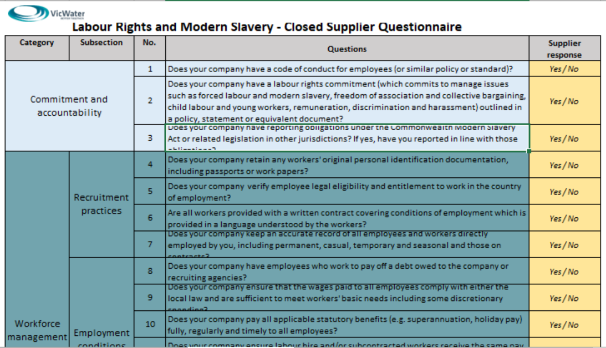

Modern Slavery Scoring Tool (Excel based)
During this reporting period, Melbourne Water developed a ‘Modern Slavery scoring tool’ to assist evaluators to score the Supplier Questionnaires as an evaluation criteria in procurement activities classified as medium to high risk. The tool was incorporated in tender evaluation documentation and training for use is scheduled to be completed during the next reporting period (FY24).

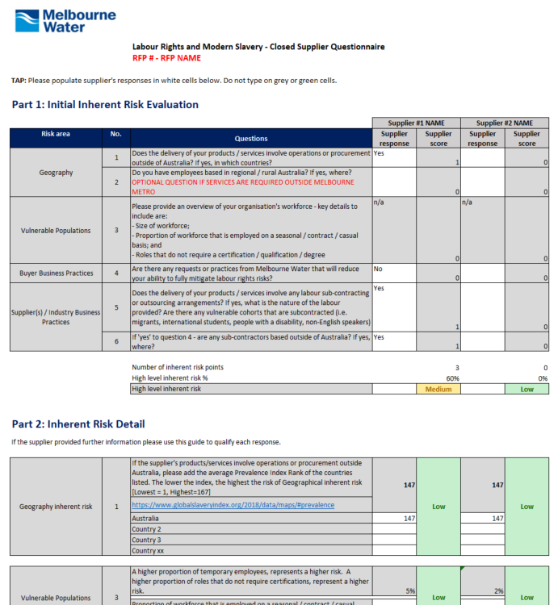
Excel based Modern Slavery Risk Scoring Tool

Modern Slavery Software Platform
Melbourne Water, in collaboration with other water authorities across Australia, through the Water Services Association of Australia (WSAA), participated in the evaluation and selection process of a digital tool to support Modern Slavery assessments and reviews. The successful platform supplier, Informed 365, was appointed toward the end of the reporting period and implementation has commenced in FY24. This Modern Slavery Software Platform aims to:
- move away from excel based tools to a single repository of Modern Slavery assessment questionnaire and management at a supplier and/or industry level. This software will allow each water authority to keep track of utilised supplier’s inherent risks as well as progress towards reducing the risk.
- make available information of shared suppliers to participating water authorities (with supplier’s consent).
- make it easier to track parent company and supply chain visibility of our suppliers modern slavery inherent and residual risks.

Melbourne Water expects this tool to be implemented and readily utilised in FY24.

Governance and procurement practices

Procurement function restructure
At Melbourne Water, the responsibility for coordinating and managing modern slavery risks lies within the Procurement and Contract Management team. In recent years, this team has embarked on a significant Procurement Transformation journey, characterised by a thorough review of its operations and a subsequent approval of strategic recommendations to build a more centre-led function. These measures have been carefully devised to strengthen our organisation's capacity to effectively mitigate a spectrum of procurement risks, including modern slavery.
During the latter part of FY23, the Procurement Transformation initiative was set into motion. As such, new roles within the procurement function have been established and recruitment is scheduled for the first half of FY24. These newly established positions include dedicated Social Procurement resources that will provide the necessary resources and expertise essential for the identification and management of procurement risks, including the critical aspect of modern slavery, across various stages of the procurement process and lifecycle.

Hybrid Procurement model at Melbourne Water
Melbourne Water's procurement model follows a hybrid approach dependent on the nature of procurement activity, whether transactional or strategic.
Transactional Procurement
Melbourne Water employs a decentralised procurement model for transactional procurement, wherein each business unit is responsible for the entire purchase-to-payment lifecycle process within the framework and systems established by the Procurement function. This means that business units independently engage with suppliers and arrange contracts for low-risk engagements. To support compliance, the Procurement function, which oversees the purchase-to-payment lifecycle, has introduced a Buying Tool. This web-based questionnaire equips Melbourne Water's Buyers with a comprehensive understanding of the various risks associated with their purchases.

Strategic Procurement
The central Procurement team takes the lead in strategic procurement initiatives, coordinating and managing high-complexity procurement activities.
Melbourne Water maintains a set of guidelines, frameworks, policies, and procedures that enable different business units to determine the level of involvement required from the Procurement team. For instance, procurement activities flagged as high risk necessitate direct engagement with the Procurement Team.
In alignment with the expectations outlined in the Commonwealth Modern Slavery Act 2018: Guidance for Reporting Entities and a commitment to continuous improvement, Melbourne Water is currently enhancing the Buying Tool to incorporate specific questions related to modern slavery. This enhancement will ensure early-stage consideration of modern slavery risks in the procurement process. Please refer to the 'Progress Update' section for more detailed information (item 1).

United Nations Sustainable Development Goals (SDGs)
Melbourne Water continues to be a signatory of the United Nations Global Compact. As such, our operations and our procurement practices are guided by the SDGs. In line with the nature of our organisation, the following SDGs are a priority for Melbourne Water and relate to modern slavery:
Taking into consideration that social, economic and gender inequalities increase modern slavery risks, Melbourne Water prioritises these SDGs in our operations and supply chain.

Supplier selection and engagement

Supplier Code of Conduct
In line with the Victorian Government Procurement Policies, all Melbourne Water tendering activity requires vendors to adhere to the Victorian Government Supplier Code of Conduct (the Code). Among other aspects, the Code requires suppliers to comply with human rights obligations and ensure that involuntary or underage labour does not take place. The Code also requires suppliers to ensure that workers are paid in line with all applicable laws and regulations and that workers are able to associate freely.

Contract terms
Melbourne Water employees are directed to use the Melbourne standard terms in procurement engagements initiated outside of the Procurement and Contract Management function. Where there are deviations from the standard terms, the Procurement and Contract Management function are engaged to ensure oversight. Melbourne Water has used standard templates with Modern Slavery clauses since its implementation and throughout the Reporting Period.
The Melbourne Water standard terms specify that suppliers are not to engage in modern slavery activities, and that suppliers may be subject to audits.

Contract register
During the Reporting Period, Melbourne Water’s Contract register platform, Zycus, has been enhanced to show fields on spend category and Risk details including Modern Slavery. The contract platform can incorporate controls and actions, residual risk rating and risk owner if required. Where applicable, new contracts added into the register will have controls and actions to reduce the risk of modern slavery.

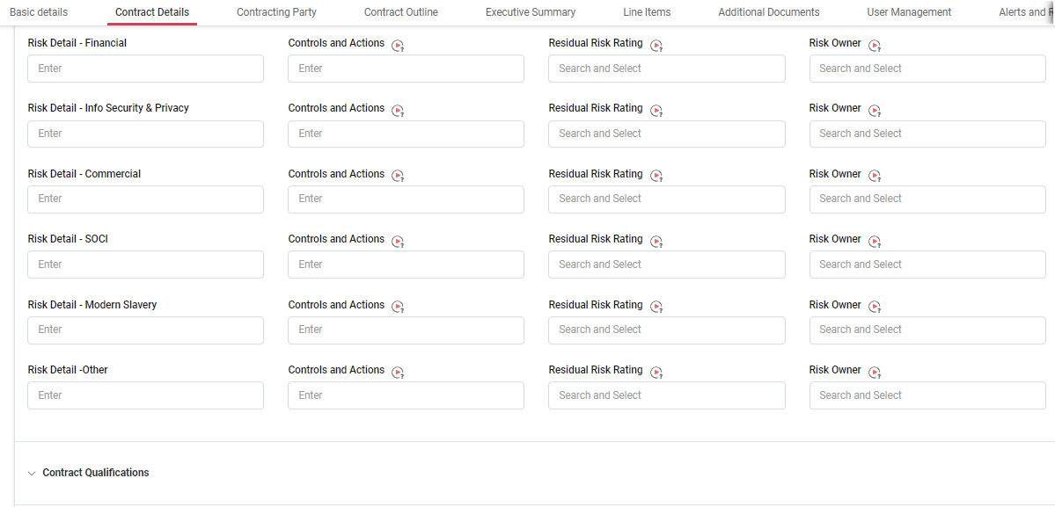
Subcontractor management

Construction Services
Melbourne Water currently works with a handful of Tier 1 service providers for construction and infrastructure maintenance. Due to the nature of the services and the requirement of Victorian Government policies and strategies such as Local Jobs First (LJF), and Social Procurement, both of which guide Melbourne Water's operations, Tier 1 contractors must report on type and number of employees and number of hours for specific roles, as well as expenditure with Tier 2 suppliers/service providers.
In addition to the above, Melbourne Water contractually requires Tier 1 contractors to acknowledge and sign a statutory declaration to confirm that workers and subcontractors have been paid in accordance with the law. Even though the purpose of these policies is slightly different, service provider compliance with these policies indirectly mitigates modern slavery risks. For example, Social Procurement aims at giving opportunities to disadvantaged cohorts (SDG 10: Reducing inequalities) and LJF aims at maintaining jobs in the state of Victoria (SDG 8: decent work and economic growth).

IT Services
Melbourne Water’s IT Managed Services Agreement involve the delivery of services through onshore and offshore staff based in India. While the Agreement was entered into before the implementation of the Modern Slavery Act, the Agreement has clauses for the supplier to manage industrial relations and ensure rates of pay and conditions of employment in accordance to the law. Melbourne Water notes that this supplier has provided their own Modern Slavery Statement to the ABF as at FY22.

Using data to identify modern slavery risks
Accurate data is a key element in managing risk. Melbourne Water uses Robobai, a Procurement environment spend analysis tool that utilises Artificial Intelligence (AI) technology to categorise and analyse spend. Having data at a category level allows Melbourne Water to identify procurement risks, including the risk of modern slavery at a category level. In addition to the categorisation benefits, Robobai is used to identify spend that is out of contract. Decreasing the amount of out of contract spend, decreases supply chain risks, including modern slavery, as the level of due diligence required to enter into a contract systematically reviews and actively seeks to mitigate the risks. During the Reporting Period, Melbourne Water has continued to train the AI to refine spend classification. Refer to ‘Progress Update’ for specific actions related to data and reporting (item 3).

Robobai helps Melbourne Water identify and manage supplier risk exposure by country. The tool does this by matching supplier information such as business name, address and ABN with publicly available indexes (e.g. Global Slavery Index) and flags high risk suppliers.

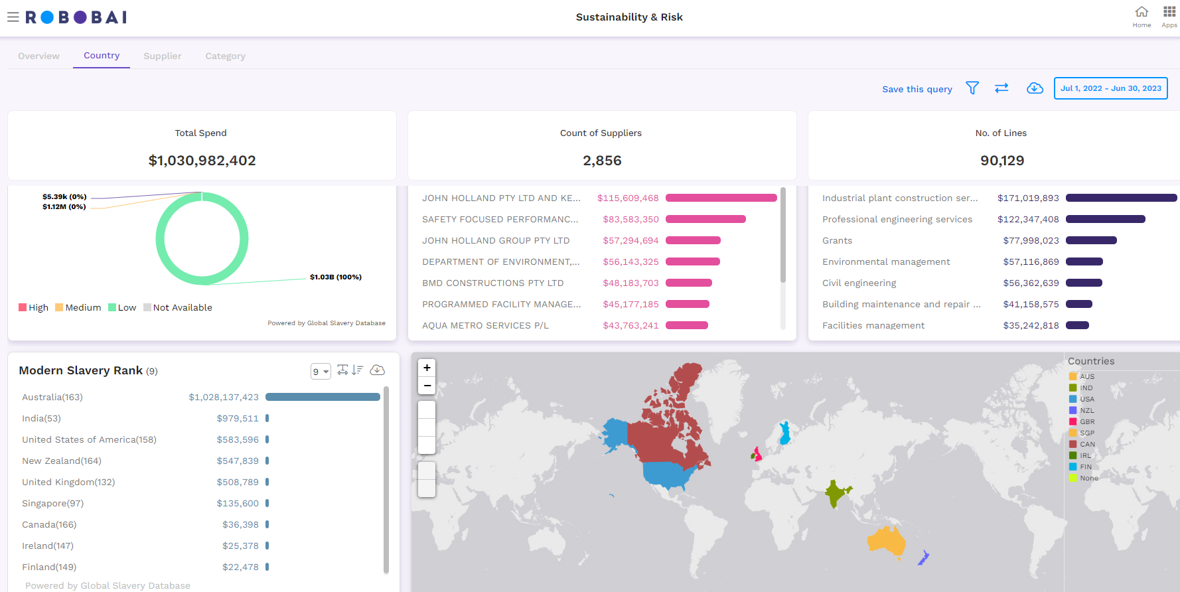
Snapshot of FY23 spend in Robobai by country.

Promoting transparency
In line with VGPB obligations, Melbourne Water periodically discloses key details, such as supplier name and goods or services procured, on contracts over $100,000 (including GST) on the Tenders Vic website, which is publicly available.

How we assess effectiveness
Internal Review
Melbourne Water continues to evaluate and assess the effectiveness of our actions to address modern slavery risks and continues to improve based on feedback from key stakeholders. For example, Melbourne Water tendering documentation allows the buyer to assess modern slavery risks through the use of the Procurement Toolkit. Where applicable, Supplier Questionnaires are used at a tendering level and are part of the evaluation criteria to select a supplier through a competitive procurement process.

Community of practice
Melbourne Water continues to work with other water authorities to share insights and actions related to modern slavery in the water industry, including the WSAA. During the Reporting Period, WSAA members jointly approached the market to select a digital platform that can improve on our existing processes to identify Modern Slavery risks, and to comply with the Modern Slavery Act through use of automation and collaboration tools specifically focussed on capturing modern slavery related data. The market engagement was led by the WSAA with Melbourne Water as a member of the evaluation panel. A digital tool was selected from compliant responses at the end of FY23 with implementation commencing in early FY24.

Practical effectiveness
Melbourne Water has a large array of policies, frameworks and procedures in place to ensure our procurement processes follow best practice governance. These provide guidance to Melbourne Water Buyers and key stakeholders in considering modern slavery risks in both our operations and supply chains. Adherence to policies, frameworks and procedures is audited periodically both internally by the Melbourne Water Internal Audit team, including through first line assurance reviews by the Procurement and Contract Management Team; and externally by Third Party Assurance specialists.
During this Reporting Period, Melbourne Water engaged a third party consultant to develop a third party risk framework in which Modern Slavery is considered as part of the Supply Chain risk domain. A deliverable of this engagement is to establish Key Performance Indicators (KPIs) to monitor Modern Slavery risk. The third party risk management framework will be completed in FY24. Refer to ‘Progress Update’ for further detail.

Progress update
Throughout this Statement, Melbourne Water has identified a number of initiatives that have commenced or have been completed in FY23. Below is a progress update on each of the activities:

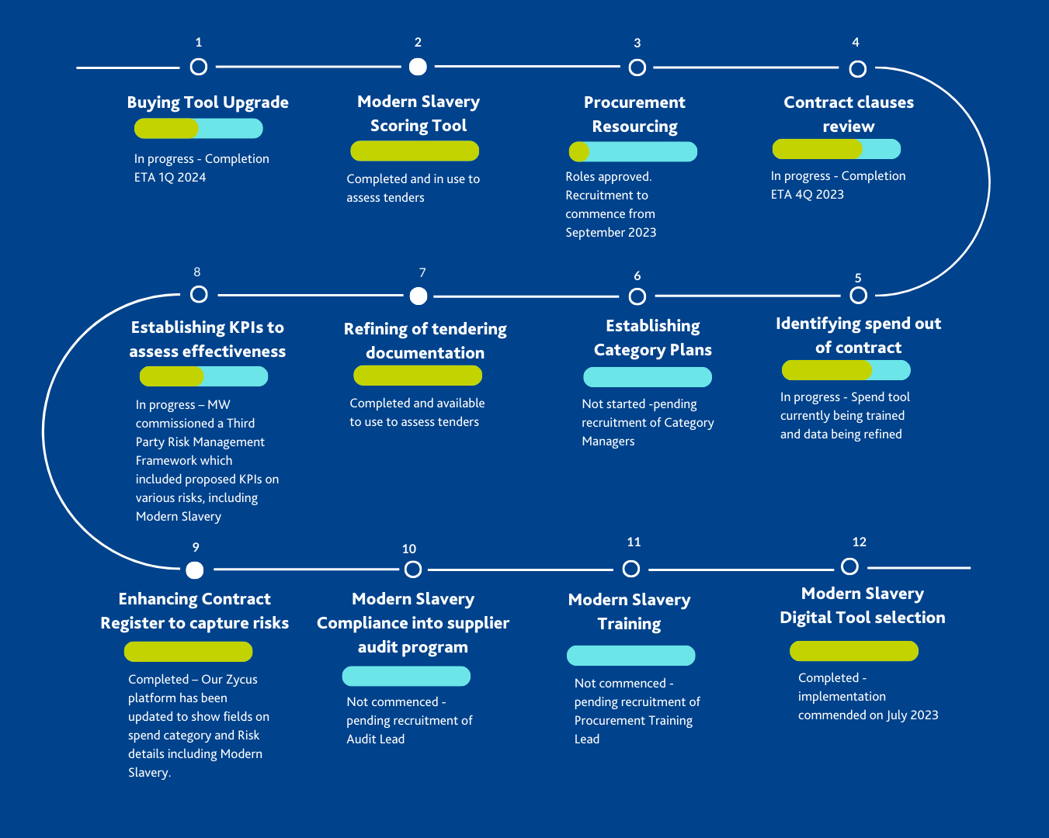

Global Slavery Index, Maps | Global Slavery Index
Global Slavery Index, Maps | Global Slavery Index
As described in our FY21 modern slavery statement, the SPWG is comprised of representatives from various Victorian water corporations, with these representatives responsible for sharing information, driving efficiencies, promoting consistency in policy and processes and supporting strategic approaches in supply chain analysis in relation to modern slavery.
For the purposes of this Statement, a Melbourne Water Buyer refers to a Melbourne Water employee who needs to engage a supplier to purchase goods and/or services that enable the organisation to deliver potable water, drainage and sewage services to our customers.
As at the time of development of the Procurement Toolkit FY18/19, Procurement provided services to each ‘Portfolio’ (Business Unit) without formally categorising expenditure as this was the structure at the time.
A Procurement Category is the grouping of similar goods or services with common supply and demand drivers and suppliers. Procurement Categories can vary depending on the nature of each organisation. Melbourne Water’s categories are built on the United Nations Standard Products and Services Code (UNPSC), which is a hierarchical convention that is used to classify products and services.
The Local Jobs First Policy requires Victorian Government Entities to procure goods, services and/or construction from businesses that create local jobs opportunities, including apprentices, trainees and cadets. Suppliers required to comply with this policy provide employment data to the Victorian Government through a specifically designed portal. The Local Jobs First Commissioner may request an audit on a specific project to any Victorian Government Entity.
Social Procurement is when organisations use their buying power to generate social value above and beyond the value of the goods, services or construction being procured. Entities that operate under the Victorian Government procurement context are required to conduct procurements taking into consideration the Victorian Government Social Procurement Framework (SPF). SPF outcomes are monitored through a specifically designed portal.

